User Guide

CMSC 495 6380

6/18/2021

Group 5

Summer Smith, Sean Dwyer, Keith Combs

**Revision History**

|  |  |  |
| --- | --- | --- |
| **Date** | **Name** | **Description** |
| 7/11 | Keith | Updated user guide to show transactions |
| 7/11 | Sean | Added guide items for starting the website, logging in, registering, and logging out |
|  |  |  |
|  |  |  |
|  |  |  |
|  |  |  |
|  |  |  |

# Starting the Website

Whether hosted locally or on a remote server, the website application itself can be started simply by running the “main.py” file in the top level of the application package. All dependencies, listed in “requirements.txt”, must be installed before the application can run. Remote hosting of the website may require additional resources to make the website available on a network; such considerations are beyond the scope of the application.

# Registration

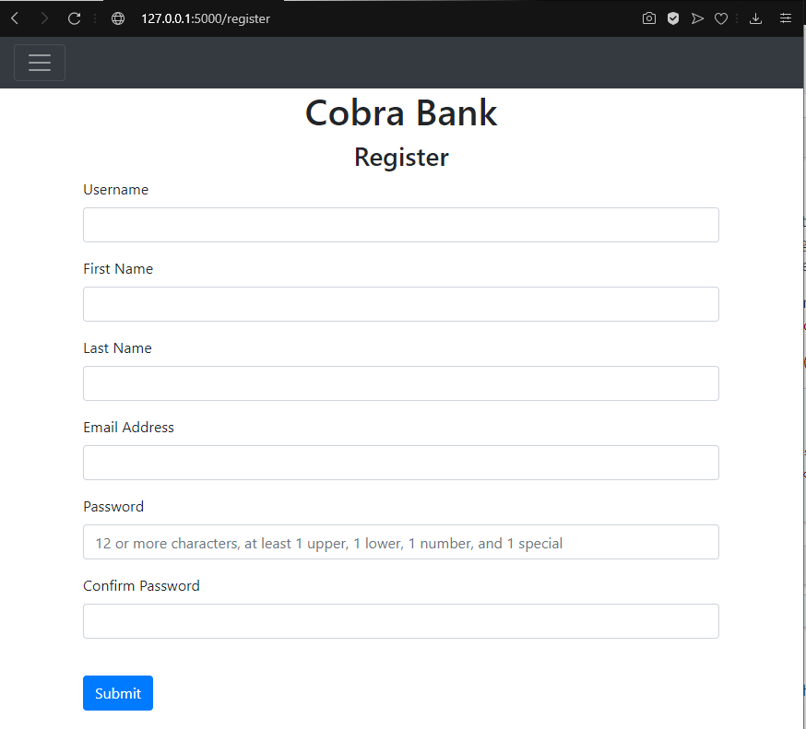

On the registration page, enter all required info, with special care placed on ensuring the password fulfills the complexity requirements and that the both of the initial password and the confirmation values match. Additionally, ensure that email addresses are valid. The user will be notified if invalid entries are made.

Upon successful registration, new savings and checking accounts will be created for the user, and the page will be redirected to the Login page.

# Login

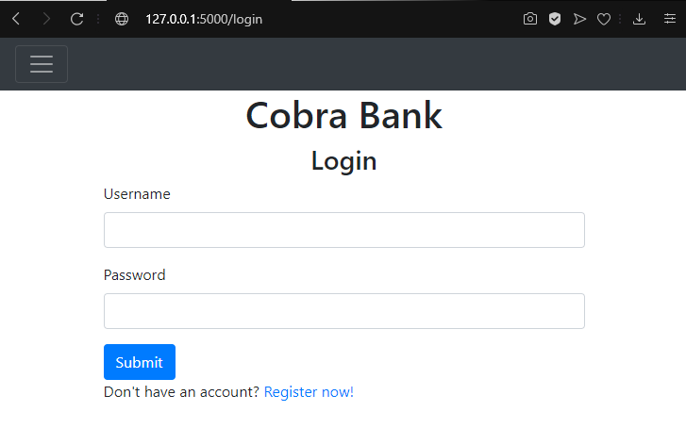

Login requires a valid username and password. If either is invalid, the user will be notified. Once the user is logged in, the page will be redirected to the homepage with the user’s account information active. Note: all login attempts, both successful and failed, are logged for security auditing.

# Logout

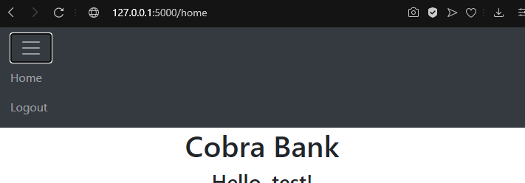

Logging out is accomplished by selecting the logout option from the navigation bar. Only logged in users can access this function. Users will be notified that they are logged out and will be redirected to the login page.

# Transactions

Login:

Example user tony, password: password

Shows Account, balance on checking and savings account.

## Initiate a deposit:

Choose Checkings and deposit and put in amount and press submit.

Example $100

Account balance increases from 4385 to 4485. Page resets to show balance.

## Initiate a withdrawal:

Choose Savings account, withdrawal and press submit.

Example: $400

Page resets to show balance.

Example: Savings balance = 5830 reduces to 5430.

## Initiate a transfer from checkings to savings:

Choose Transfer from checkings to savings

Example: $100

Page resets to show reduced amount in Checking account and increased amount in savings:

Example: Checking reduced from 4485 to 4385 and savings increased from 5430 to 5530.

## Initiate a transfer from Savings to Checkings:

Example $100

Page resets to show reduced amount in Checking account and increased amount in savings:

Example: Savings reduced from 5530 to 5540 and checkings increased from 4385 to 4485.

## Overdraft

If a user chooses to withdraw more than they have in either their Checkings or savings. An overdraft fee will occur and they will accrue a 20 dollar fee.

Example: Withdrawing 5000 from Checking.

Page resets and user now has a negative balance and a $20 fee applied.

